**Manual Aronoff Business Rules**

Prior to beginning the Scheduling process, MOD confirms the STATUS of all events that are not marked as FIRM. If event has highly likelihood of being FIRM, change STATUS to FIRM.

MOD remove status of FIRM from lines with a strikethrough in FIRM. (This could also be accomplished by having another selection of CANC, rather than strikethrough FIRM.)

Complete the anticipated event time in column J TIME

To create the Avail listing for the Floor Supervisors to input their available days:

From the Calendar worksheet, select the month.

Filter the month sheet.

Filter column H Status = FIRM

Filter column D which has a heading of E = any selection with a P (Performance) as an option, such as P, P/L, L/P.

Create columns for Beginning and Estimated End Time.

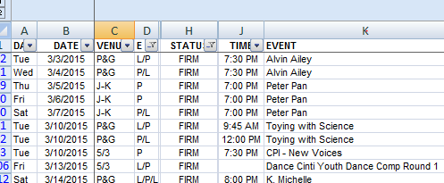

Create monthly FS Avails form.

Add a column to the Calendar titled Avail which identifies the Performance line as an AM or PM shift. PM shift is anything that has a Floor Supervisor shift beginning at 4 pm or later. Other performances are AM.

Create a new spreadsheet by copying columns from the Calendar of

Day

Date

Avail

MOD delete duplicated lines for the same day and avail, ex. Two evening performances on the same day but different theaters.

If there are two Education shows during the day, MOD determine if that is one shift or two.

This will provide the available days for the Floor Supervisor word doc.

**Or** you could change the Floor Supervisor avail input doc to be the spreadsheet with only the days that have performances and not all of the days of the month. This is a major change for the Floor Supervisors to complete.

Example file named “Aronoff test avail.xlsx”

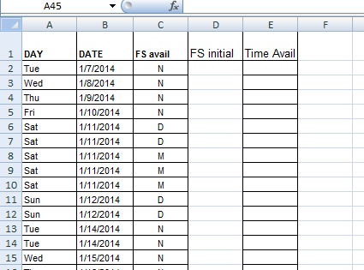

Email Floor Supervisors the Avail file with Return date required.

Create New Excel file from Scheduling template file. Save the new file using name of month and year for name.

Copy following columns from Calendar file to the new Month/Year file

A = Day

B = Date

C = Venue

D = E (optional)

E= Status (optional)

J=Time

K=Event

In New Scheduling file, there are 19 static columns. One column for each of the Floor Supervisors, I used initials. It’s easier to keep track of rather than trying to go with anonymity.

One column for Shift column K, MOD will enter the number of Floor Supervisors necessary for that event.

The formula in the cells for Shift is =IF(C22="P&G",4,1)

For events that require more or less Floor Supervisors, the MOD will overwrite the cell with the number of Floor Supervisors.

Example an Education event in P&G with all floors open and needing bus supervisors, that may require 7 floor supervisors.

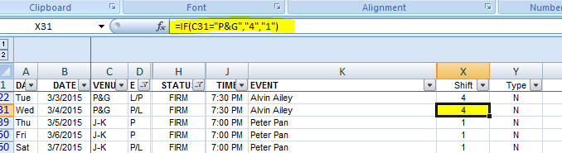

At the bottom of column K, there is a formula to sum the number of available shifts for the month.

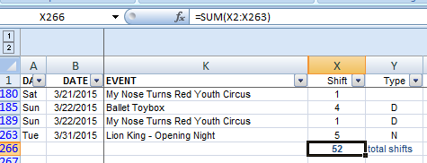

Next in column J, enter code for type of event

E = Education

D = Double

M = Matinee

N = Night

New column L, per Day, has a formula to sum the number of Floor Supervisors who have said they are available for that day’s event.

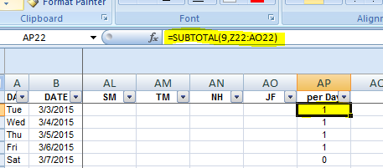

MOD enters in cell K50 the number of shifts that will be assigned to an MOD from the list of FS avails.

Any event that does not have enough FS to handle the number of shifts will highlight in Red in the cell. MOD must elicit new Floor Supervisor avails prior to assignments.

At the bottom of column L, there is a formula to sum the number of available Floor Supervisors shifts for the month.

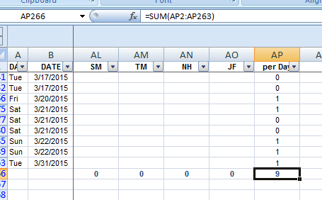

Percentage of available shifts to available floor supervisors is the formula in cell K54

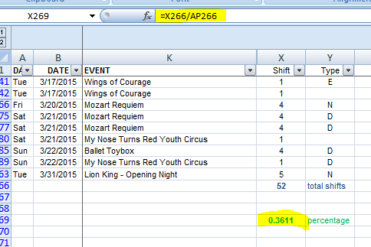

After all of the Floor Supervisors have submitted their avails to the MOD, if using the old form, the MOD will fill in the spreadsheet with a “1” in the cell for the supervisor’s schedule.

Each supervisor has a column heading with their initial.

If using the new format file, the MOD could copy & paste into the calendar the schedule from the floor supervisor.

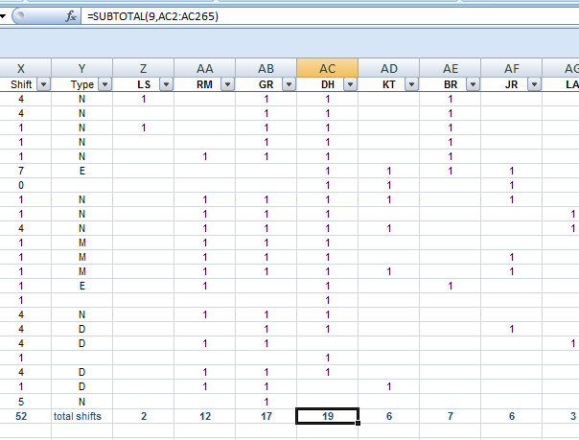

The total of the supervisor’s avails will appear at the bottom of their column.

Below the supervisor’s avails, the Percentage of shifts is calculated.

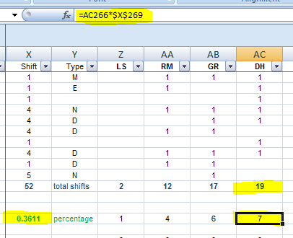

Copy the row of floor supervisor shifts percentage, Row 56 to a new row beneath. When pasting the data, use Paste Values. The new row will be the values that will decrease as assignments are given.

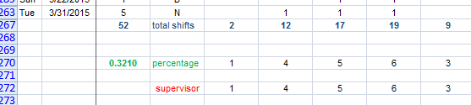

Row 55 has a formula to count the number of assignments which will decrease the number of avails in row 56.

Assignments are noted by changing the “1” in the table to an “A”.

|  |  |  |
| --- | --- | --- |
| **Rules** |  |  |
| Education macro. | | |
|  | | |
| Note number of supervisors necessary for event | | |
| Note supervisor avails by number of avails highest number first | | |
| Note profile of supervisor for special positions | | |
| Assign supervisor by inserting an A in cell. | |  |
|  | Start with lowest "per Day" event | |
|  |  | |
|  | Assign supervisor with highest number of avails | |
|  |  | |
|  | Continue assignment by highest number of avails and profile and tracking of avails until all Education events filled | |
|  |  |  |
| Daily Double macro. | |  |
|  | | |
| Note number of supervisors necessary for event | | |
| Note supervisor avails by number of avails highest number first | | |
|  | | |
| Assign supervisor by inserting an A in cell. | |  |
|  | Start with lowest "per Day" event | |
|  |  | |
|  | For Doubles only, begin with supervisors who are available for both events | |
|  | Assign supervisor with highest number of avails | |
|  |  | |
|  | Continue assignment by highest number of avails and profile and tracking of avails until all Double events filled | |
|  | Do not assign back to back days | |
|  | If remaining doubles have not been assigned, begin assignment following Single even workflow | |
|  |  |  |
| Matinee macro. | |  |
|  | | |
| Note number of supervisors necessary for event | | |
| Note supervisor avails by number of avails highest number first | | |
|  | | |
| Assign supervisor by inserting an A in cell. | |  |
|  | Start with lowest "per Day" event | |
|  |  | |
|  | Assign supervisor with highest number of avails | |
|  |  | |
|  | Continue assignment by highest number of avails and profile and tracking of avails until all Matinee events filled | |
|  | Do not assign back to back days | |
|  |  |  |

|  |  |  |
| --- | --- | --- |
| Night macro. | |  |
|  | | |
| Note number of supervisors necessary for event | | |
| Note supervisor avails by number of avails highest number first | | |
|  | | |
| Assign supervisor by inserting an A in cell. | |  |
|  | Start with lowest "per Day" event | |
|  |  | |
|  | Assign supervisor with highest number of avails | |
|  |  | |
|  | Continue assignment by highest number of avails and profile and tracking of avails until all Single events filled | |
|  | Do not assign back to back days | |